**Market Segmentation**

**Analysis of EV Market In India**

**By:**

**Shreyas Om**

**Nabnita Dutta**

**Keerthavana VS**

**Ruchita Suryawanshi**

**Github Link:**

[**https://github.com/IAmTheBlueDragon/Electric-Vehicle-Analysis**](https://github.com/IAmTheBlueDragon/Electric-Vehicle-Analysis)

**Background**

India has been actively working towards reducing its carbon footprint and promoting the use of electric vehicles. In 2013, the government launched the National Electric Mobility Mission Plan (NEMMP) to encourage the adoption of electric and hybrid vehicles in the country.

The Indian EV market is dominated by two-wheelers, which account for the majority of the EVs sold in the country. In recent years, there has been a surge in the demand for electric cars, especially in the fleet segment. The government has also announced various incentives and subsidies to promote the adoption of EVs, such as tax exemptions, subsidies on the purchase of EVs, and investment in charging infrastructure.

Some of the major players in the Indian EV market include Tata Motors, Mahindra & Mahindra, Hero Electric, Ather Energy, and Revolt Motors. There has also been a rise in the number of startups working towards developing new and innovative electric vehicles.

Despite the progress made in recent years, the Indian EV market still faces various challenges, such as the lack of adequate charging infrastructure, high upfront costs of EVs, and limited range of electric vehicles. However, the government and various stakeholders are actively working towards addressing these challenges and promoting the adoption of electric vehicles in the country.

**Year On Year Growth of the EV market:**

Year wise Growth of EV Market

The market for electric vehicles in India was estimated to be worth USD 220.1 million in 2020, and from 2021 to 2030, it is anticipated to increase at a CAGR of 94.4%. During the forecast period, market expansion is predicted to be fueled by the alluring incentives being granted by the Indian government on the manufacturing and purchase of electric vehicles to promote the adoption of electric vehicles. Sales of both passenger and commercial automobiles fell significantly overall in 2020 because of the COVID-19 pandemic outbreak. In India, however, there was no change in the sales of electric vehicles. An important aspect boosting the electric vehicle market in India is the post-lockdown sale of pure and hybrid electric automobiles.

Fig: Growth of India EV market

The growth of electrification in vehicles is anticipated to be accelerated by the rising costs of conventional gasoline. The government's strict pollution regulations and Indian customers' rising environmental consciousness are also anticipated to increase demand for electric vehicles. Also, substantial attempts have been made by Indian manufacturers to include electrified vehicles in their product lineup, including Tata Motors and Mahindra & Mahindra Ltd. This is expected to influence Indian consumers to choose electric vehicles. The growth of the electric vehicle market in India during the anticipated term is encouraged by all these factors.

India is regarded as one of the leading nations in the global auto sector. Several businesses are actively setting up factories in India. For instance, Dana TM4 Inc. declared plans to build a manufacturing facility in Pune, India, in September 2020. The new 4,600 square metre plant would manufacture electric motors, vehicle control systems, and Dana TM4 low- to high-voltage inverters. The Phase-II of the Faster Adoption and Manufacturing of Electric Vehicles (FAME) programme of the Indian government aims to accelerate the uptake of electric mobility while also fostering the growth of its manufacturing eco-system. The following pillars will be used to implement Phase-II of the FAME scheme: encouraging the demand for EVs; conducting awareness campaigns, including publicity and information, education, and communication (IEC) efforts; and developing a charging infrastructure.

Almost 96% of the market's total revenue was contributed by the BEV segment in 2020. The segment's dominant market share can be attributed to consumers' growing preference for EVs over ICE cars and regulations on vehicle CO2 emissions. BEVs have the potential to drastically lower vehicle emissions as well as the long-term cost of ownership. Over the projected period, it is also anticipated that improvements in battery technology and falling lithium-ion battery prices will fuel demand for BEVs.

Hyundai Motor India, Tata Motors, Mahindra & Mahindra Ltd, Audi AG, BMW AG, MG Motor India Pvt. Ltd., and Olectra Greentech Ltd are some of the major companies that dominated the industry in 2020. These market participants provide a variety of electric vehicles, such as electric buses, light commercial vehicles, and passenger automobiles. The corporations are putting a lot of effort into releasing cutting-edge, technologically superior products on the market. To strengthen their position in the market, they are also exploring strategic initiatives like mergers and acquisitions, strategic partnerships, and collaborations. For instance, the ride-hailing service Uber announced a cooperation with India's Lithium Urban Technologies, a fleet operator for electric vehicles, in October 2020. The collaboration envisages the two companies deploying over 1,000 electric vehicles for Uber India’s Rentals and Premier ser Some of the prominent players operating in the India electric vehicle market are:

Audi AG

BMW AG

Hyundai Motor India

Jaguar Land Rover Limited

Mahindra & Mahindra Ltd

Mercedes-Benz AG

MG Motor India Pvt. Ltd.

Olectra Greentech Limited

Tata Motors

Toyota Motor Corporation

**Segmentation Plan**

To find the appropriate marketing strategy we need to answer four major questions, where to market (geographic segmentation), whom to market (target customer analysis) and what to market (ideal product Analysis).

Geographic analysis: In this we try to find locations that are suitable for adoption of electric vehicles. This can be determined by analysing existing ev owners in a place, and existence of services such as charging stations, etc. Even if the public of a locality be willing to accept electric vehicles, lack of such services can create difficulty in adoption of the technology and hence will cause a failure in the marketing strategy.

Target customer Analysis: This would be the central to it all as who are the ideal people who are willing to adopt the newfound tech and are also willing to pay for the adoption process is the most important question that needs to be answered. Identifying the target customer is crucial for any industry as that would be the founding of the company’s revenue stream. Once such a customer base has been established the base can be branched out for more varied customer base.

Ideal product: This would be product that would tailor to the target customer requirements and would be realistic to produce. In this we would look at existing products and their pricings to make a general estimate on what the product would be priced at. How much profit would be made off such a product would entirely be dependent on the production policy of the company.

**Geographical Segmentation:**

Data sources:

<https://e-amrit.niti.gov.in/charging-station-locators>

<https://pib.gov.in/PressReleaseIframePage.aspx?PRID=1778958>

<https://pib.gov.in/PressReleasePage.aspx?PRID=1842704>

This data base gives us the idea of which states have the most number of electric vehicles owned and which states have the most amount of charging stations.

On the basis of this analysis the state of Uttar Pradesh is the most effective state to market the product as it has the highest number of EV owners and also the most number of electric charging stations.

Detail Analysis: <https://github.com/IAmTheBlueDragon/Electric-Vehicle-Analysis/blob/main/Geographic_Segmentation.ipynb>

**Ideal Customer Analysis:**

Data source: Self survey from a google form. <https://forms.gle/y4GnTpuoxBRCejVZ9>

Data pre-processing steps:

* Changing the location and entered data into unique variable for each location.
* Changing the list of segments into strings to be analysed easily.
* Assigning Boolean value for each segment
* Preform similar step for concerns and get dummies for each categorical data.
* Preform PCA analysis.
* Find the ideal number of segments using elbow method and silhouette score.
* Perform k means clustering on the data and find ideal segments using aggregate mean.

Machine learning techniques:

* K means clustering
* PCA analysis

Due to the lack of the data on customer opinions on the cars and electric vehicles a survey had to be conducted on our own to get the ideal kind of data to be analysed. The data was broken down into 7 segments as follows:

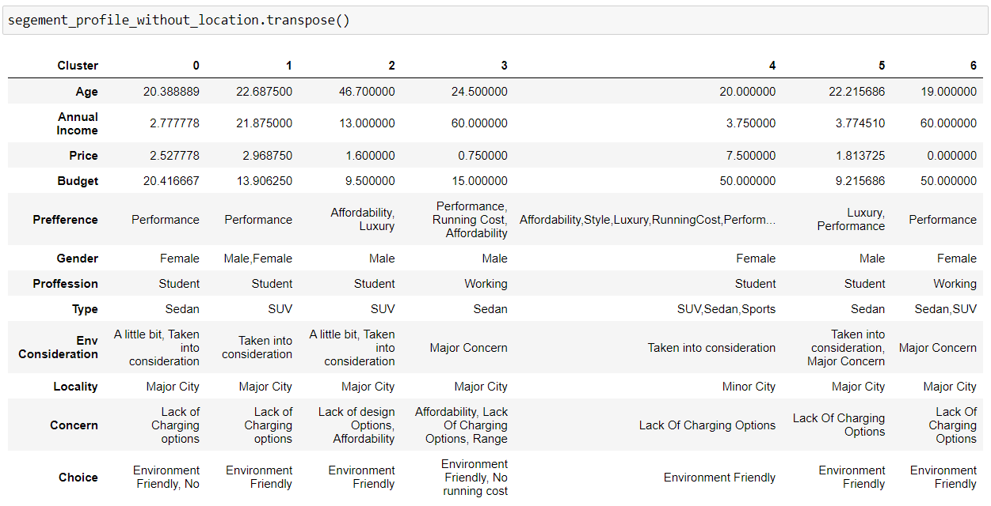

Although this data is a bit flawed being a self-preformed survey, but it creates a good picture about the consensus of the public opinion on the EV market.

On initial analysis we see that segment 3 and segment 6 are the ideal customers for the data. But on a closer look we see that the 6th segment is of age of 19-year-olds. This makes us question the legitimacy of this segment hence we stick to the 3rd segment of the analysis.

The 3rd segment has the following characteristics.

* General age of 24.5-year-old males hence mid 20 individuals.
* Annual income of this group is around 60 lakh rupees and that makes top 1% earners in India.
* This segment is willing to put forth about 75,000 rupees more to get an electric vehicle.
* The ideal budget for a car would be 15 lakhs for this segment and they prefer for it to be a sedan.
* The three major concerns they have is the range of the vehicle, charging options and affordability.
* The locality of this segment is mostly major cities.

This data gives us a picture of the target segment we have. This target segment can be marketed both to male and female and the ideal budget for the car also cover segment 0,1 and 3.

This expands our target segment from 1% of Indian population to 3.2% as per government reports of annual incomes in 2018 and 2019 although those numbers are likely to be risen by now.

This makes the target customer to be about 400 million Indians.

Detail analysis of data: <https://github.com/IAmTheBlueDragon/Electric-Vehicle-Analysis/blob/main/Customer_Segementation.ipynb>

**Ideal Product Analysis:**

Data source: <https://www.kaggle.com/code/sjsumanth/ev-segmentation/notebook>

Data pre-processing method:

* Covert all the supposedly numerical data into float data.
* Changing categorical data into Boolean data.
* Perform PCA analysis.
* Find the ideal number of segments using elbow point and ARI score.

Machine learning techniques:

* PCA Analysis
* K means clustering

This data base contains the detail of types of cars and there currently in the market. This analysis would only give us a general idea and would not influence the product greatly as it would be given that the company would make their own products that are unique to themselves.

The data was segmented into 4 segments and represented a quite varied set of products. The segments were as follows:

This creates a problem and an opportunity. The cars fitting the segment that was first analysed are SUVs and the car that was requested by the segments were a Sedan as a result it creates a demand for sedan EVs in the market which can be exploited for our benefit.

Detail analysis: <https://github.com/IAmTheBlueDragon/Electric-Vehicle-Analysis/blob/main/Product_Segementation.ipynb>

**Pricing And Market Size:**

Pricing of the ideal car would be easy as it would align with the budget plus the extra price the segment is willing to pay.

That makes the ideal cars pricing to be around **16 lakhs**. This is the pricing of a mid-segment car in India.

The market size as we can see is around 3.2% of the country. Although there exist a lot of competitors in this segment, we can see that most of them lack the insight of making the car a sedan that appeals to this segment. Still if we can capture even 10% of this market, it would be in accordance with the marketing analogy.

Now we will have to factor in the adoption rate of EV markets. We have observed from year-on-year growth of electric vehicles that only 2% of people are adopting electric vehicles.

This would make the capturable market size to around **9.5 lakh** people in the country.

This makes the market size of this kind of car to be: **9.5 lakh * 16 lakh * 0.1 = 1520 crores**

Hence the potential market size of the product can be of 1520 crores.